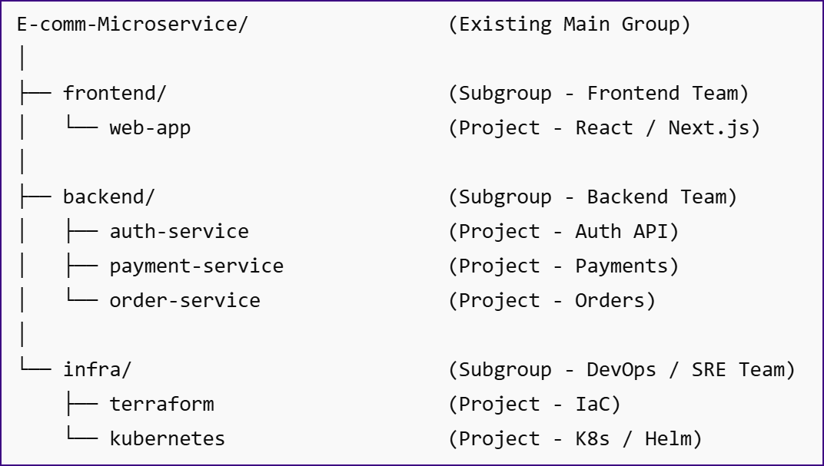
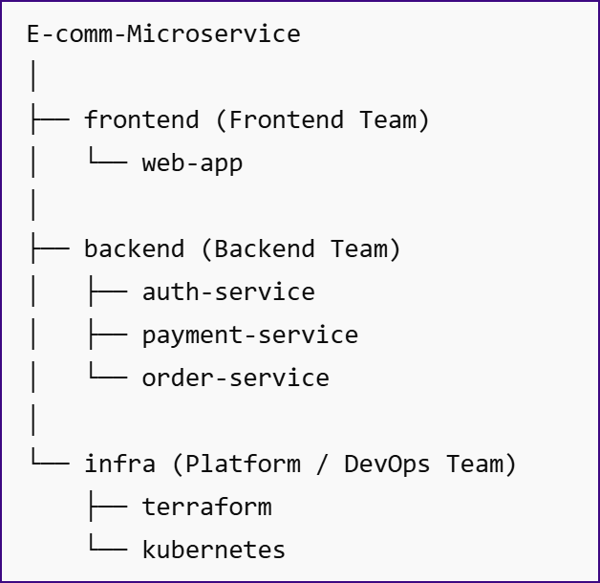
Get the ID Of the group.

Where to run it
Run it from:
Git Bash / WSL / Linux / macOS terminal
For Windows, prefer Git Bash or WSL, not PowerShell.

Step 1: Create GitLab Access Token
GitLab → Profile → Preferences → Access Tokens
Give scope:
api
Copy the token.

Step 2: Create script
Create file:
create-gitlab-structure.sh
Paste this:
#!/bin/bash

GITLAB_URL="https://gitlab.com"
TOKEN="PASTE_YOUR_TOKEN_HERE"
PARENT_GROUP_ID="PASTE_EXISTING_GROUP_ID_HERE"

create_group() {
local name=$1
local path=$2
local parent_id=$3

response=$(curl -s --request POST "$GITLAB_URL/api/v4/groups" \
--header "PRIVATE-TOKEN: $TOKEN" \
--data "name=$name" \
--data "path=$path" \
--data "parent_id=$parent_id" \
--data "visibility=private")

id=$(echo "$response" | grep -o '"id":[0-9]*' | head -1 | cut -d ':' -f2)

if [ -z "$id" ]; then
echo "Failed to create subgroup: $name"
echo "$response"
exit 1
fi

echo "$id"
}

create_project() {
local name=$1
local namespace_id=$2

response=$(curl -s --request POST "$GITLAB_URL/api/v4/projects" \
--header "PRIVATE-TOKEN: $TOKEN" \
--data "name=$name" \
--data "namespace_id=$namespace_id" \
--data "visibility=private")

id=$(echo "$response" | grep -o '"id":[0-9]*' | head -1 | cut -d ':' -f2)

if [ -z "$id" ]; then
echo "Failed to create project: $name"
echo "$response"
exit 1
fi

echo "Created project: $name"
}

echo "Creating subgroups inside existing group..."

FRONTEND_ID=$(create_group "frontend" "frontend" "$PARENT_GROUP_ID")
BACKEND_ID=$(create_group "backend" "backend" "$PARENT_GROUP_ID")
INFRA_ID=$(create_group "infra" "infra" "$PARENT_GROUP_ID")

echo "Frontend ID: $FRONTEND_ID"
echo "Backend ID: $BACKEND_ID"
echo "Infra ID: $INFRA_ID"

echo "Creating projects..."

create_project "web-app" "$FRONTEND_ID"

create_project "auth-service" "$BACKEND_ID"
create_project "payment-service" "$BACKEND_ID"
create_project "order-service" "$BACKEND_ID"

create_project "terraform" "$INFRA_ID"
create_project "kubernetes" "$INFRA_ID"

echo "Done."
Step 3: Run it
chmod +x create-gitlab-structure.sh
./create-gitlab-structure.sh./

